Contents
Click on the section that you are interested in.

1 About this Part 2
2 Corporate Mobile Plus Plans 2

Certain words are used with the specific meanings set in Part A – General of the Telstra Mobile section, or in the General Terms of Our Customer Terms.

About this Part

This is part of the Telstra Mobile section of Our Customer Terms. Provisions in other parts of the Telstra Mobile section, as well as in the General Terms of Our Customer Terms, may apply.

See clause 1 of the General Terms of Our Customer Terms for more detail on how the various sections of Our Customer Terms should be read together.

See clause 1 of Part A – General of the Telstra Mobile section for more detail on how the various parts of the Telstra Mobile section should be read together.

From time to time, Telstra may include extra content or value add services within the minimum monthly charge of any plan in this Part. Such extra content or value add services may be available for a limited time.

Corporate Mobile Plus Plans
Not available for new service connections or service changes from 01 January 2023 and discontinued from 30 March 2023.
Availability

Unless we otherwise agree, Corporate Mobile Plus is not available to new or recontracting customers on and from 18 August 2020.
Eligibility

To be eligible to connect mobile services under Corporate Mobile Plus, you must have:

an ABN, ACN or ARBN; and

a current Corporate Mobile Plus customer agreement with us.

Services connected to plans other than Corporate Mobile Plus Plans can’t be on the same account as services on Corporate Mobile Plus Plans.

Corporate Mobile Plus Plans are not available with any other Telstra offer unless advised by us otherwise.
Plan type

Corporate Mobile Plus Plans are casual month-by-month plans.

You are only eligible to connect mobile services to the Corporate Mobile Plus Plans set out in your Corporate Mobile Plus customer agreement.

If you entered into a Corporate Mobile Plus customer agreement before 20 July 2016 (including recontracts and extensions on substantially the same terms), the following terminology describes your plan in clause 3:

Terminology appearing in your Corporate Mobile Plus customer agreement entered into before 20 July 2016 | Terminology used in clause 3
“Corporate Mobile Plus Plan” | Basic $20, Entry $40, Standard $60, Professional $80, Executive $120, Data SIM $5, and Data SIM $40 Plans
“Corporate Mobile Plus Mobility-as-a-Service Plan” | National and Global Plans

Mobile handsets

For each Corporate Mobile Plus Plan, you must either:

bring your own compatible mobile handset; or

purchase one from us.

Where permitted in your Corporate Mobile Plus customer agreement, you may purchase an eligible mobile handset on a 24 month Mobile Repayment Option (MRO) when you connect a mobile service to an eligible Corporate Mobile Plus Plan. The MRO terms and conditions are set out in Part C – Special Promotion of the Telstra Mobile Section of Our Customer Terms.
Payment and eligible usage

Each month, you must pay us:

the minimum monthly access charges for your mobile services connected to a Corporate Mobile Plus Plan;

any minimum monthly charges for your Committed Data Plans;

any excess use or Eligible Usage not included in your Corporate Mobile Plus Plan (subject to our FairPlay Policy);

any MRO handset repayments; and

any other services that you use through your Corporate Mobile Plus Plans.

Your Corporate Mobile Plus Plan may include a monthly allowance (Monthly Call Allowance) to use towards the following usage:

most types of national direct dial voice calls, video calls, SMS and MMS messages made in Australia to standard Australian numbers;

voice calls to 1800, 11xx, 13xx, and 12xx numbers (excluding Sensis® 1234, 12455 and 12456 services);

standard national SMS and MMS messages sent to mobile numbers on an Australian network within Australia;

calls and SMS to most satellite mobiles;

MessageBank® Standard diversion and retrieval calls;

diversion of calls to fixed numbers in Australia with an 02, 03, 07 or 08 area code and mobile numbers in Australia commencing with 04xx but excluding diversion to any other number;

if you have a Corporate Mobile Plus Basic $20 Plan, eligible data usage in Australia and standard international direct dialling calls from Australia (including connection charges); and

any other calls or messages as determined by us,
(Eligible Usage).

Eligible Usage cannot be used for other call types including information calls, Call Answers, Memo and Phone Page, third party content calls, international calls and messages, international roaming calls and messages, premium SMS and MMS, reverse charges calls, calls to Sensis® 1234, 12455, 12456 and calls to 19xx, calls to Pivotel mobiles and any other calls or messages as determined by us.

Unless otherwise set out in your Corporate Mobile Plus customer agreement, the included monthly allowances for Eligible Usage for your Corporate Mobile Plus Plans are described further in clause 2.42.

Any unused allowance expires at the end of each month.
FairPlay Policy

Our FairPlay Policy – Business Use (as set out in Part A - General of the Telstra Mobile section of Our Customer Terms) applies to Corporate Mobile Plus Plans except that terms relating to excessive use do not apply to any unlimited Eligible Usage of a Corporate Mobile Plus Plan. For the purpose of this clause, data volumes are calculated in accordance with clause 2.33.

In addition to the Our FairPlay Policy, you must not use, or allow others to use any service connected to a Corporate Mobile Plus Plan:

as a point of interconnect for calls from overseas into Australia;

in connection with any machine-to-machine applications (i.e. any automated telemetry, telematics or telemetrics application which links two or more systems or devices with a mobile data connection);

to establish any point to point connections with another modem; or

to send messages to any numbers that we reasonably believe have been set up to enable you or another person to commercially exploit our services.

Any use of a Corporate Mobile Plus Plan in a way described in clause 2.16 is a material breach incapable of remedy and we may immediately suspend or cancel your service without notice to you.
International calls allowance

Your Corporate Mobile Plus Plan may include a monthly allowance for calls and SMS to standard international fixed and mobile numbers (Monthly International Call Allowance) as set out in 2.42.

Any unused Monthly International Call Allowance expires at the end of each month.
International roaming allowance

Your Corporate Mobile Plus Plan’s monthly access charge may include an overseas roaming allowance for voice calls, SMS and/or data usage in Eligible Countries as set out in 2.42 (Monthly International Roaming Allowance). The list of Eligible Countries is set out in clause 10 of Part I – Heading Overseas – International Roaming of the Telstra Mobile Section of Our Customer Terms. Any unused Monthly International Roaming Allowance expires at the end of each month.

If you exceed your Monthly International Roaming Allowance, subject to clause 2.42, you will be charged for any additional data usage in an Eligible Country and standard international roaming charges for all other usage and for all usage in countries other than Eligible Countries in accordance with the charges set out in Part I – Heading Overseas – International Roaming of the Telstra Mobile Section of Our Customer Terms.

The included allowances provided with your Corporate Mobile Plus Plan (including your unlimited Monthly Call Allowance, your Monthly International Call Allowance and Monthly International Roaming Allowance (if any)) cannot be shared between any other services connected on your Corporate Mobile Plus account.
International roaming DAY PASS

On and from 21 May 2018, if international roaming is activated on the mobile services connected to the Corporate Mobile Plus Plans on your account at the time you connected these mobile services to the Corporate Mobile Plus Plans, then you also agree to take up an International Roaming $10 Day Pass (IR Day Pass) for each mobile service connected to a Corporate Mobile Plus Plan on your account (except Executive and Global Plans) on the terms set out in clause 12 of Part I – Heading Overseas – International Roaming of the Telstra Mobile Section of Our Customer Terms (IR Day Pass Terms). The IR Day Pass will be charged to your account when it is activated according to the IR Day Pass Terms.
Service Level Packs

If your Corporate Mobile Plus Plan has a minimum monthly access charge of $40 or more (excluding Data SIM Plans), then you can choose to have a MessageBank® Plus Pack or Voice2Text Pack (each a Service Level Pack). Your handset must have iOS 4.3 or above to use MessageBank Plus.

You may cancel a Service Level Pack at any time.

We do not charge you a monthly access fee to use MessageBank Standard with your Corporate Mobile Plus Plan. Other MessageBank Standard charges continue to apply and are set out in Part F – Managing Calls of the Telstra Mobile section of Our Customer Terms.
Data usage

In addition to our rights under the FairPlay Policy, if you exceed the monthly included data allowance in Australia for your mobile service on an eligible Corporate Mobile Plus Local or National Plan each month for three consecutive months, we may move your service to an eligible Corporate Mobile Plus National or Global Plan of the same type with the next higher minimum monthly access charge. This change to your service will apply from the next billing month, without further notice to you.

Example: if you have a National Data SIM $100 plan, and exceed your data allowance as described in this clause, we may move your service to a Global Data SIM $160 plan.

If we reasonably believe that you are in breach of our FairPlay Policy due to excessive data use on your Local, National or Global Plan, we reserve the right (but do not automatically) charge the following standard applicable retail rates for data use exceeding your FairPlay allowances on your Local, National and Global Plans:

0.8c per Mb for data use in Australia; and

our standard international roaming charges set out in Part I – Heading Overseas – International Roaming of the Telstra Mobile Section of Our Customer Terms for data use outside Australia.

If you have a:

Local, National or Global Plan, we consider that use exceeding the allowances in clause 2.42 to be excessive use for the purpose of our FairPlay Policy; or

Basic $20, Entry $40, Standard $60, Professional $80, Executive $120, Data SIM $5, Data SIM $40, X-Large Data SIM BYO or XX-Large Data SIM BYO Plan, we will charge you for data usage according to clause 2.39.

The applicable data charging method will be selected in your Corporate Mobile Plus customer agreement with us and will apply to all Basic $20, Entry $40, Standard $60, Professional $80, Executive $120, Data SIM $5 and Data SIM $40 Plans under that agreement.

Eligible data usage for the purposes of this section is described in Part G – Data Services of the Telstra Mobile Section of Our Customer Terms. We will only charge you up to $500 per month per service (Cap) for all your eligible data usage. Amounts we charge you for data usage for international roaming do not count towards the Cap amount.

When calculating data volumes in this section:

where the volume of data transferred is not a whole number of kilobytes, it is rounded up to the next kilobyte at the earlier of the end of each session or 24 hours; and

1024 bytes = 1 kilobyte (KB) and 1024 kilobytes = 1 megabyte (MB)
Committed Data Plan

A Committed Data Plan is:

a month-to-month add-on which provides a monthly data allowance (Monthly Data Allowance) that expires at the end of each month; and

available with Entry $40, Standard $60, Professional $80, Executive $120, Data SIM $5 and Data SIM $40 Plans.

Your Monthly Data Allowance under your nominated Committed Data Plan will be automatically pooled and shared with the Monthly Data Allowance of services on eligible Corporate Mobile Plus Plans on the same account (Shared Monthly Data Allowance).

You can change or cancel your Committed Data Plan at any time, unless otherwise set out in your Corporate Mobile Plus customer agreement. Any change or cancellation will apply to all Corporate Mobile Plus Plans eligible for the Committed Data Plan on your account. The terms applying to these changes are as follows:
Change | Terms
If you move to a lower Committed Data Plan | We will apply your new allowance (unless you move to PAYG Data charges) and excess data rates from the next billing cycle.
If you move to a higher Committed Data Plan | We will apply your new allowance and data charges from the next billing cycle.
If you move to PAYG Data charges | Your current data allowance will expire at the next billing cycle. We will apply your excess data rates from the next billing cycle.

This table sets out what will happen to your Shared Monthly Data Allowance if you make a change to Corporate Mobile Plus Plan associated with Committed Data Plan in between billing months:
Change | Terms
Cancelled | Any unused data as at the date of cancellation will remain on your account for the remainder of that billing month.
Added | A full month’s data allowance will be added to your Shared Monthly Data Allowance for the month (it will not be pro-rated).
Moved to another account | The total data contributed to the Shared Monthly Data Allowance by the relevant service will be removed from the original account.  If the data used by the relevant service is greater than the data contributed, the maximum data removed from the Shared Monthly Data Allowance of the original account will be data used by relevant service.  If the data used by the relevant is less than the data contributed, then only the data used will be deducted from the Shared Monthly Data Allowance of the original account for the applicable month.

If your Corporate Mobile Plus Plan is no longer available, we may migrate your mobile service onto another current plan which is reasonably comparable. We will tell you before this happens.
Data charges

You will be charged for data usage as follows:
Data Construct | Committed Data Plan minimum monthly charge | Shared Monthly Data Allowance (GB) | Tiered Data Rate (Per MB or part thereof) applicable to the Data Usage in excess of the Shared Monthly Data Allowance
 |  |  | 0-1GB | >1GB to 2GB | >2GB to 3GB | >3GB to 4GB | >4GB to 5GB | >5GB
PAYG (Basic $20) | N/A | N/A | 3.0c/MB | 3.0c/MB | 3.0c/MB | 3.0c/MB | 3.0c/MB | 3.0c/MB
PAYG (Entry $40, Standard $60, Professional $80, Executive $120, Data SIM $5 or Data SIM $40) | N/A | N/A | 2.0c/MB | 1.5c/MB | 1.2c/MB | 1.0c/MB | 0.9c/MB | 0.8c/MB
Committed Data Plan (1GB) | $15 per service | 1GB x Service(s)* | 1.5c/MB | 1.2c/MB | 1.0c/MB | 0.9c/MB | 0.8c/MB | 0.8c/MB
Committed Data Plan (2GB) | $24 per service | 2GB x Service(s)* | 1.2c/MB | 1.0c/MB | 0.9c/MB | 0.8c/MB | 0.8c/MB | 0.8c/MB
Committed Data Plan (3GB) | $30 per service | 3GB x Service(s)* | 1.0c/MB | 0.9c/MB | 0.8c/MB | 0.8c/MB | 0.8c/MB | 0.8c/MB
Committed Data Plan (4GB) | $36 per service | 4GB x Service(s)* | 0.9c/MB | 0.8c/MB | 0.8c/MB | 0.8c/MB | 0.8c/MB | 0.8c/MB
Committed Data Plan (5GB) | $40 per service | 5GB x Service(s)* | 0.8c/MB | 0.8c/MB | 0.8c/MB | 0.8c/MB | 0.8c/MB | 0.8c/MB
Committed Data Plan (7.5GB) | $45 per service | 7.5GB x Service(s)* | 0.8c/MB | 0.8c/MB | 0.8c/MB | 0.8c/MB | 0.8c/MB | 0.8c/MB
Committed Data Plan (10GB) | $50 per service | 10GB x Service(s)* | 0.8c/MB | 0.8c/MB | 0.8c/MB | 0.8c/MB | 0.8c/MB | 0.8c/MB
Committed Data Plan (20GB) | $55 per service | 20GB x Service(s)* | 0.8c/MB | 0.8c/MB | 0.8c/MB | 0.8c/MB | 0.8c/MB | 0.8c/MB
Local, National and Global Plans | N/A – FairPlay Policy applies
X-Large and XX-Large BYO Data SIMs | These plans include a monthly data allowance (see clause 2.42) that is not shareable.  Excess data is charged at 0.8c/MB.
* ‘Service(s)’ means any mobile service(s) connected to a Corporate Mobile Plus Plan eligible to have a Committed Data Plan on the same account in a billing month.
Cancelling and changing monthly spend

You can cancel your Corporate Mobile Plus Plan at any time. There is no early termination charge (ETC) at service level (ETCs may apply when you cancel your Corporate Mobile Plus customer agreement) but you must pay any costs incurred up to the point of cancellation, including any minimum spend and services commitments in your Corporate Mobile Plus customer agreement. If you change or cancel your Corporate Mobile Plus Plan during a billing cycle, you will receive a pro-rata refund of your monthly charge and your included call allowance will be pro-rated for that billing cycle.

You may move mobile services to another Corporate Mobile Plus Plan with a different minimum monthly access charge no more than once every three months as long as you continue meeting any minimum spend and minimum number services commitments in your customer agreement.
Charges and inclusions

Unless otherwise set out in your Corporate Mobile Plus customer agreement with us, the following charges and inclusions apply to your Corporate Mobile Plus Plans (refer to the above sections for further data inclusions and rates):
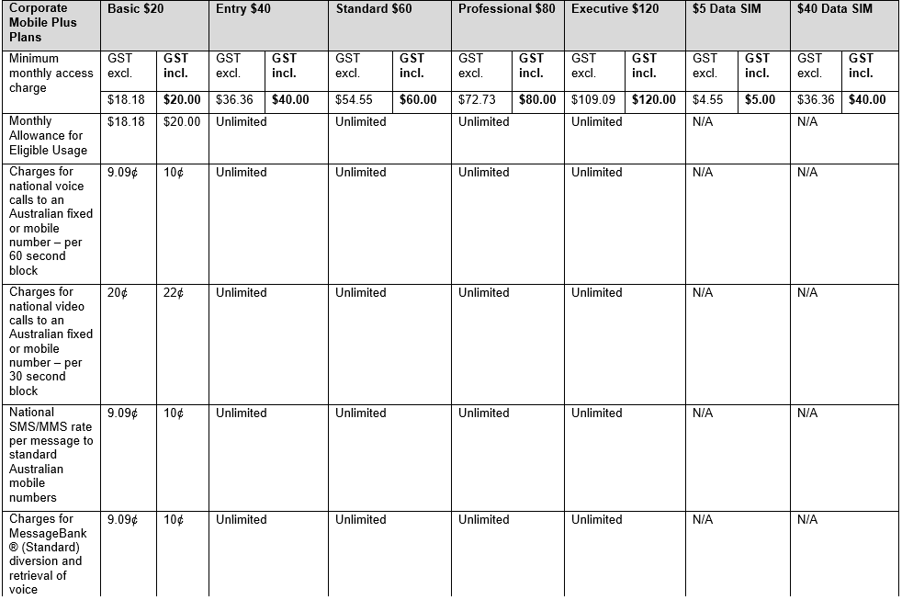
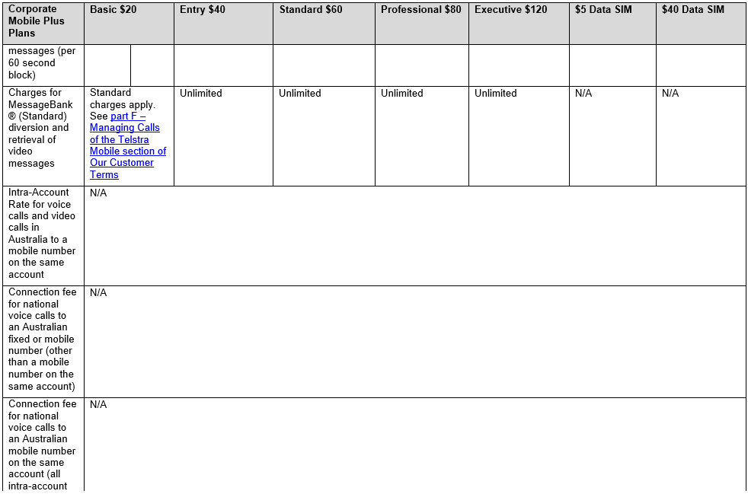

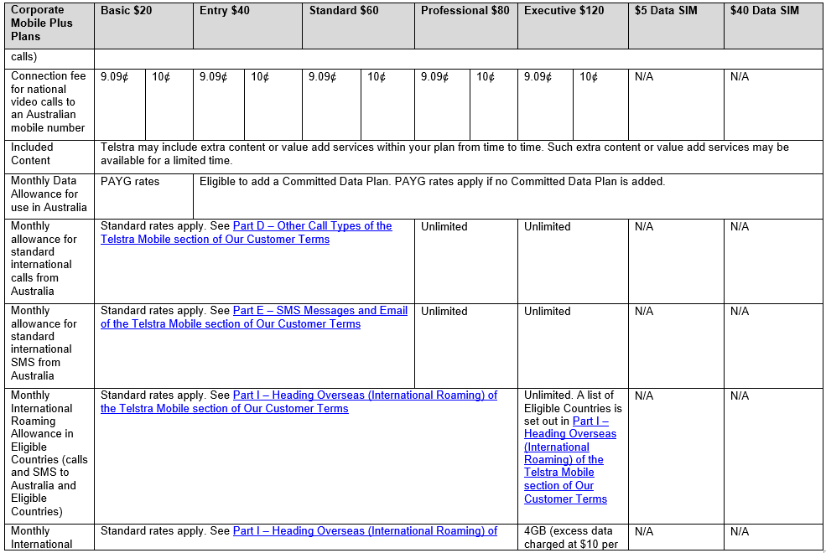

Corporate Mobile Plus Plans | Basic $20 | Entry $40 | Standard $60 | Professional $80 | Executive $120 | $5 Data SIM | $40 Data SIM
Roaming Allowance in Eligible Countries (data) | The Telstra Mobile section of Our Customer Terms |  |  |  | 1GB, valid for 31 days. A list of Eligible Countries is set out in
 |  |  |  |  | Telstra Our Customer Terms Part I - Heading Overseas (International Roaming)

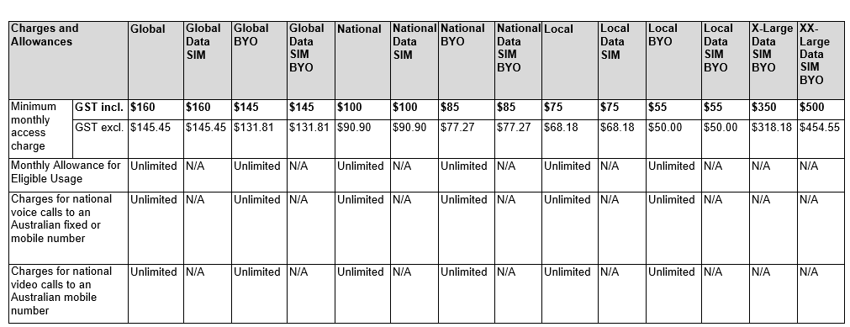

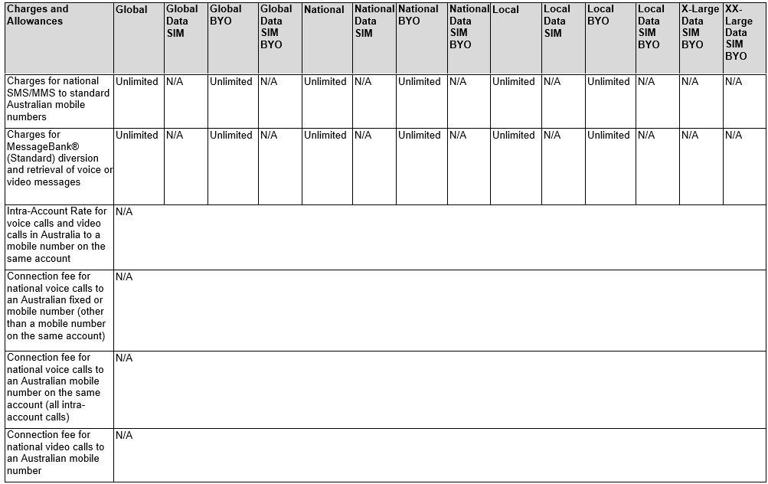

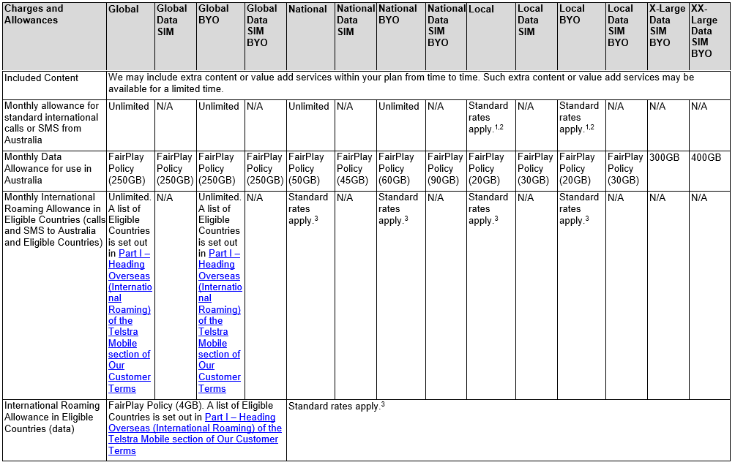

1. For calls, see Part D – Other Call Types of the Telstra Mobile section of Our Customer Terms
2. For SMS, see Part E – SMS Messages and Email of the Telstra Mobile section of Our Customer Terms
3. See Part I – Heading Overseas (International Roaming) of the Telstra Mobile section of Our Customer Terms

